CS008

Brody Childs and Treuvor Holowinsky

Assignment: CS008 Final Project Website

Clean Burning Black Rocks Inc. Website

Version <1.0>

Table Of Contents

Time Log 3

Introduction 4

Purpose 4

Definitions, acronyms, and abbreviations 4

Overall Description 4

Story Board 5

Specific requirements 6

|  |  |  |  |
| --- | --- | --- | --- |
| Time Log | | | |
| Estimated time to complete assignment => | | | 100 Hours |
| Date | Time Spent  (in hours) | Description | Author |
| 10/10 | 1.5 | First Version of Software Requirements | Brody Childs, Treuvor Holowinsky |
| 11/8 | 1 | Began deciding what the website should be, Setup GitHub | Brody Childs, Treuvor Holowinsky |
| 11/10 | 2.5 | Planned some of the pages on the website, Began coding index.php | Brody Childs |
| 11/11 | 2 | Finished backend of Homepage | Brody Childs |
| 11/13 | 0.75 | Created a storyboard for some more pages | Treuvor Holowinsky |
| 11/13 | 1 | Worked on general improvements, Fonts, Toolbars completed, More planning on web dev | Brody Childs, Treuvor Holowinsky |
| 11/15 | 1 | Switched pages around, fixed css, improved flexboxes | Brody Childs |
| 11/15 | 1 | Figured out more github pull/push mechanics, edited About page, and tested a new font | Treuvor Holowinsky |
| 11/15 | 2 | Finished Front End for a lot of pages, Worked on linking News CSV to News Feed | Brody Childs |
| 11/15 | 2 | Worked on getting data for the news CSV, tested font that is now used for the site | Treuvor Holowinsky |
| 11/17 | 1 | Got the news page working, Linked the investors page to the news page correctly | Brody Childs |
| 11/27 | 1 | Added data to the articles data file, Began working on the forums | Brody Childs, Treuvor Holowinsky |
| 11/29 | 4 | Added forum elements to invest page, Redid forum CSS, Added various items | Brody Childs |
| 11/29 | 1 | Finished the CSV file for news | Treuvor Holowinsky |
|  |  |  |  |
|  |  |  |  |
|  |  |  |  |
|  |  |  |  |
|  |  |  |  |
|  |  |  |  |
|  |  |  |  |
|  | 20.25 | <=Total Time Spent |  |
|  |  |  |  |

# Introduction

### Purpose

The purpose of this document is to describe the requirement specification for the web site “Clean Burning Black Rocks Inc”.

The intended audience for this document is the customers of Clean Burning Black Rocks Inc in an effort to show them the product and encourage them to invest.

### Definitions, acronyms, and abbreviations

ER Diagram – a diagram to represent the data you want to save with your system

W3 Validation – refers to both Html and CSS validation tool provided by the W3c.org. the html validator is located at:

<http://validator.w3.org/>

with the CSS validator located at:

<http://jigsaw.w3.org/css-validator/>

CBBR – a shortened form of clean burning black rock

# Overall Description

The site’s purpose is to show the potential clients of Clean Burning Black Rocks Inc the companies main product: a form clean burning black rock. The website needs to be easy to use and guide the user to whatever page they may be searching for quickly and easily without much fuss. Ideally the website will have a modern tone and represent the highly advanced nature of Clean Burning Black Rocks Inc.

# Story Board

About Page

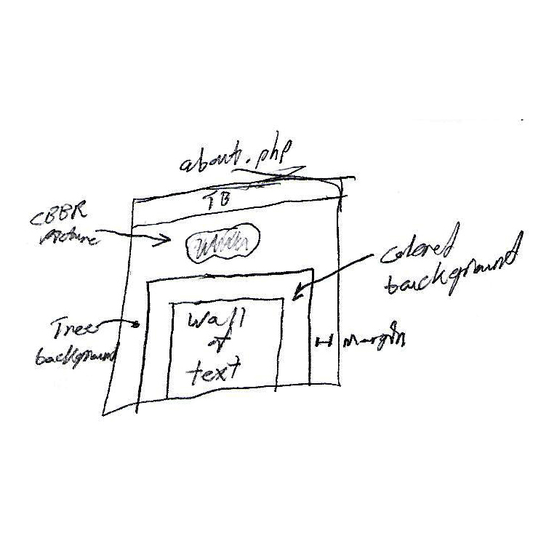

Index Page

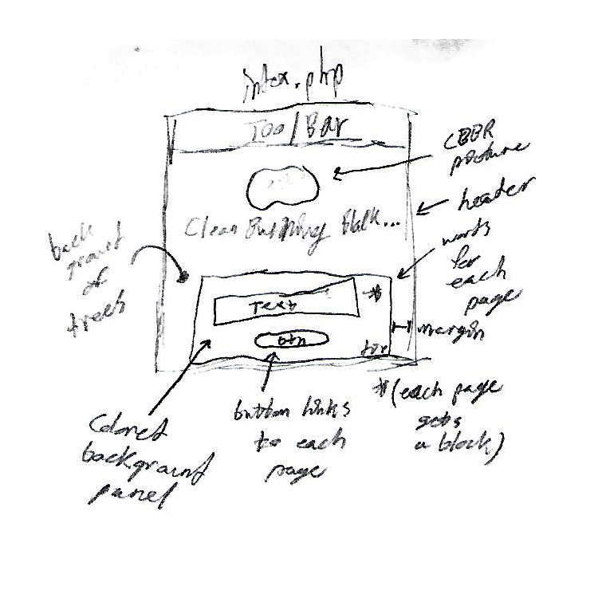

Invest Page

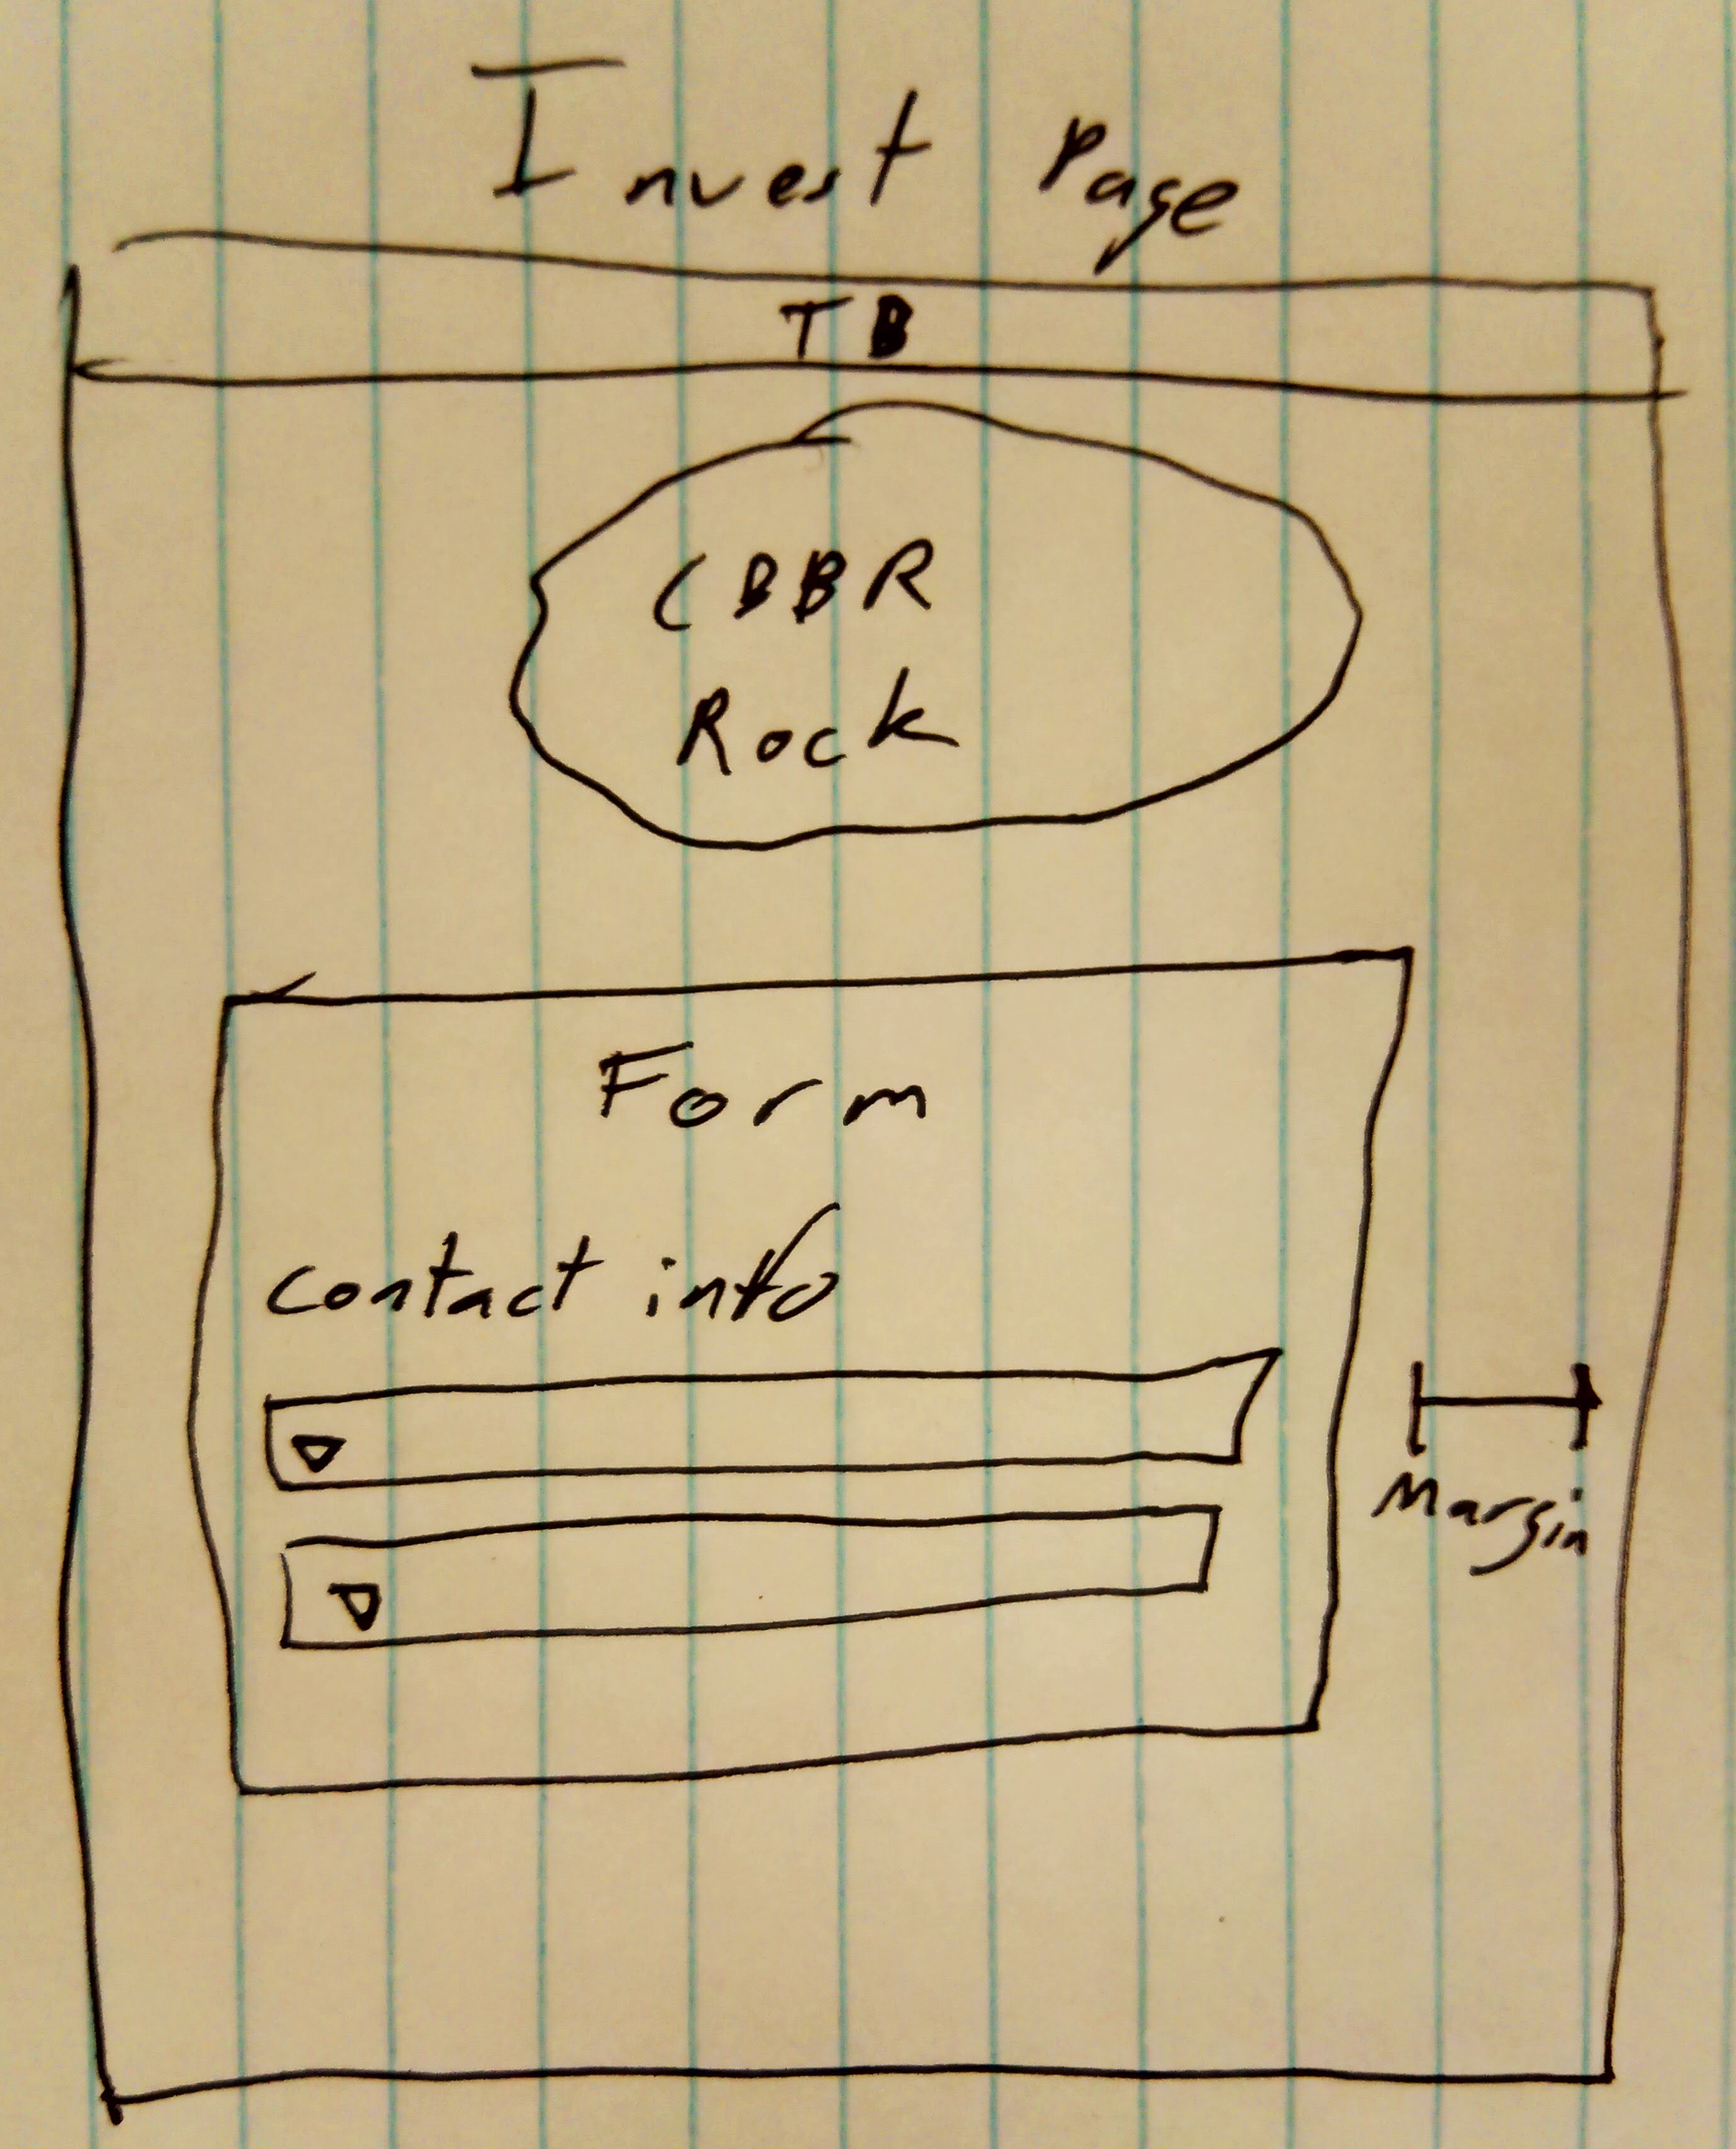

Investors Page

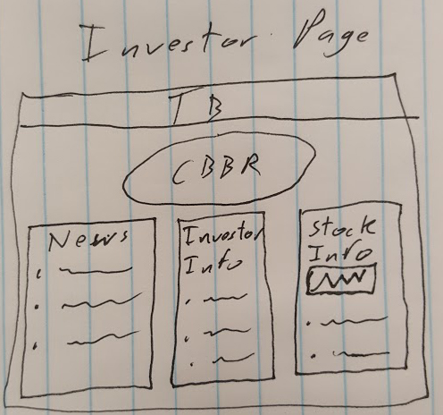

Join Page

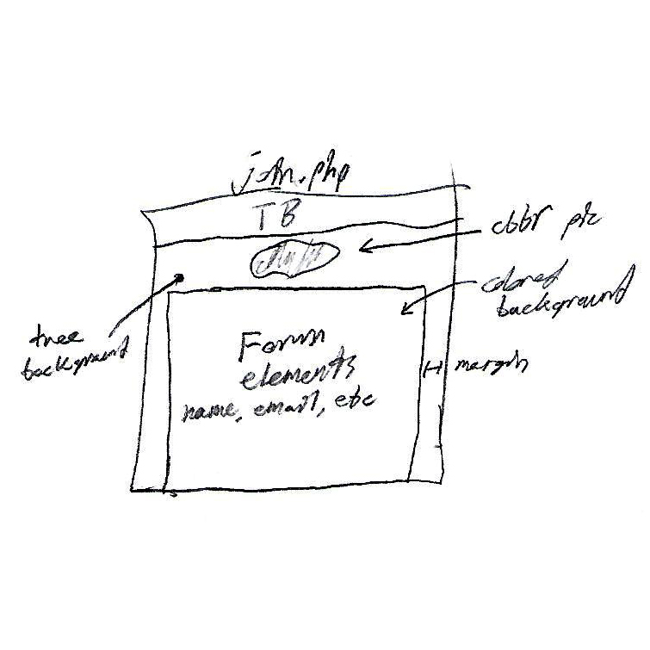

News Page:

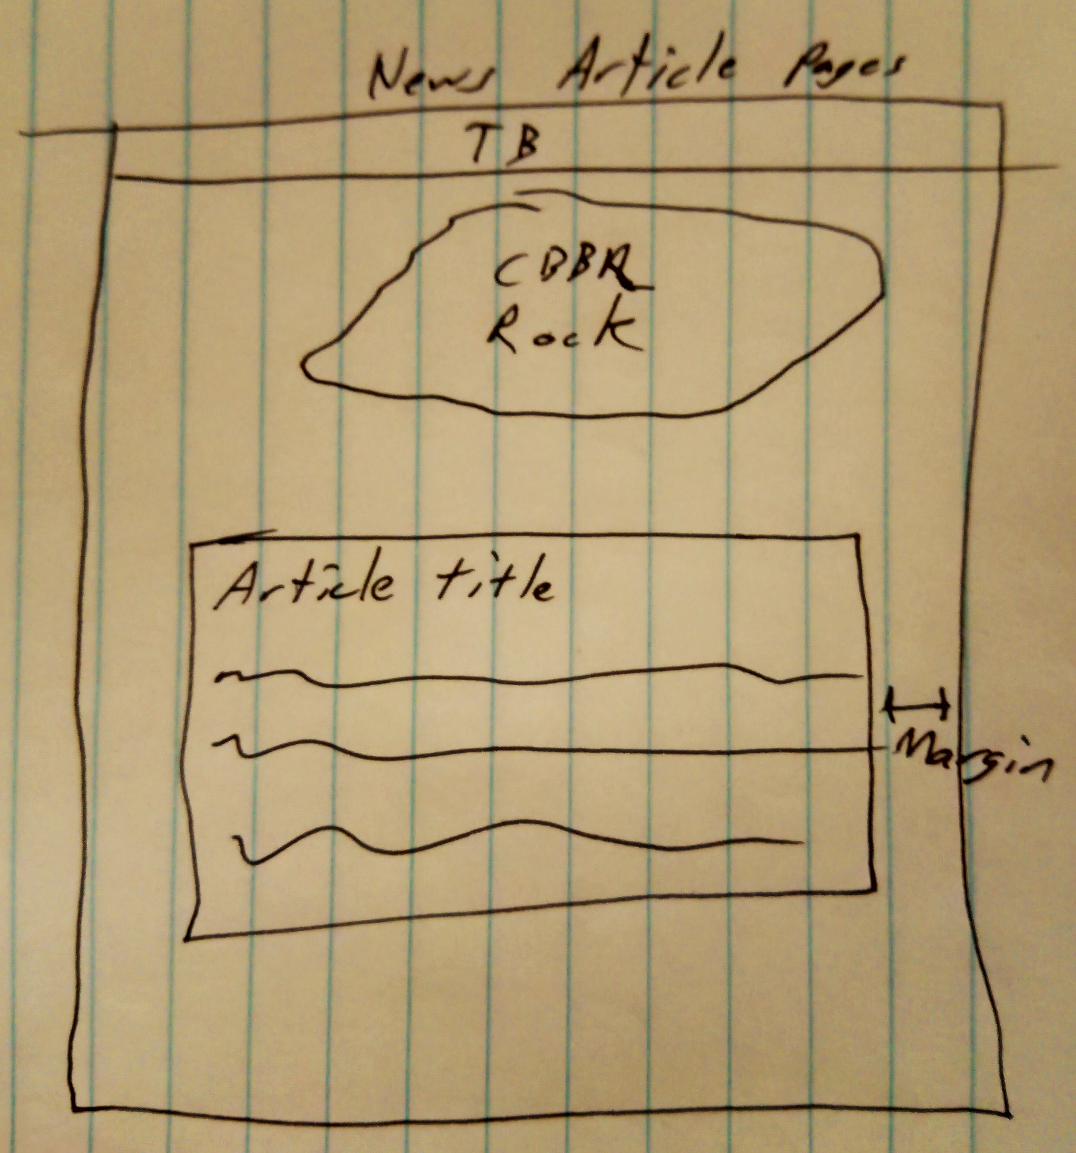

# Specific requirements

1. *Title for website*: Clean Burning Black Rocks Inc.
2. *Meta Description*: Clean Burning Black Rocks Inc. official website. Home of the revolutionary Clean Burning Black Rock or 'CBBR'.
3. *Meta Character set*: UTF - 8
4. *Logo*: Clean Burning Black rock image (cbbr.png)
5. *Background Image*: Something with nature in it (treesBackground.jpg)
6. *Toolbar*: Shows all pages except News Page
7. *Main page content*: Links to other pages (not the news page) and some description of each page.
   1. Separate box for each link and description item.
   2. Show the company’s name above the logo. (Don’t do this on any other page.)
8. *About page content*: Text that describes the company.
   1. Prompts people to join the company newsletter.
   2. Has picture of man holding CBBR item (cbbrHands.jpg)
9. *Join page content*: Form that allows a user to join the newsletter.
   1. Full Name, Email, Gender, Donation Level, and Donation Focus should be collected.
   2. Emails the user a copy of their data.
   3. Saves the data to our server.
10. *Investors page content*: Shows news articles and most recent investors. As well as CBBR Inc’s current stock.
    1. News, Investors, and Stock should be different panels.
    2. Investors should only show investors that have chosen a Public investment.
    3. Each element of News should open to a news page loaded from data.
11. *News page content*: Loads news from the data file.
    1. Shows beginning of the news article.
    2. Shows title of the news article.
    3. Shows link (appended) of the news article.
    4. Allows user to click on link to go to website that hosts article.
12. *Invest page content*: Form that allows a user to sign up as an investor.
    1. Full Name, Email, Account Type, Investment Amount, and Investor Message should be collected.
    2. Emails the user a copy of their data.
    3. Saves the data to our server.